OVERALL PROGRAMME EVALUATION REPORT
Sisters’ Blended Value Program (Sbvp)Social Entrepreneurship Development Program (SEDP) Advance Module 3 Zambia (26th January 2026 - 30th January 2026)
No. of Respondents: 13
No. of Participants: 123
Response Rate: 11%
--------------------------------------------------

Faculty Reports

Dr. William Karani Murithi - Establishing Social Impact Measuring /Social Impact
Evaluation Parameter | (%) Individual Score | (%) Programme Average
Punctuality (Commencement and Completion of Sessions) | 95 | 95
How well do you understand the core concepts presented? | 87 | 91
Rate your confidence in applying the new skills learnt | 92 | 92
Degree of Faculty preparedness for the sessions | 93 | 95
Content and methodology of the program | 95 | 96
Quality of class and group discussions | 87 | 95
The information presented in the course is relevant to my work (ministry) | 95 | 92
Average scores | 92 | 94

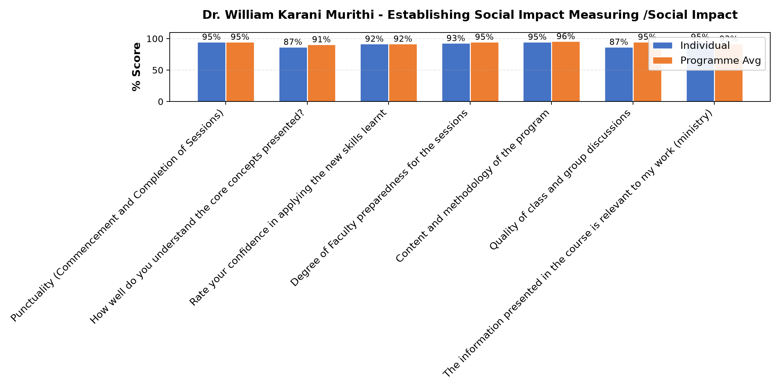

Comments & Feedback
- • Well done
- • This was a very practical topic. Where I could have been left behind, I was carried along. Wonderful
- • To see what i leant to pu into action and have friuts,in my bussines.
- • Very effective to my project, thanks so much
- • Mr. William his a good presenter
- • Thank you for today work. I understood some of the concept, some area he was a little bite too fast to fully understand. Otherwise he is great. If possible kindly send the notes so that we write what we missed out. Thanks a lot.
- • As for outing I am so impressed with the work the SJ are doing. It really requires energy and passion. Father has taught me how passion and determination work together. I have learnt how organic food is grown as how many of the products they produce and ends at our tables without knowing. I have learnt how organic food is healthy and what different mixtures they do to come up with the manure to fertilize the soil. Thank a lot it was a beautiful experience as well my first to reach Kasia.
- • Was very insightful

Dr. Chilumba Bwalya - Funding Sources
Evaluation Parameter | (%) Individual Score | (%) Programme Average
Punctuality (Commencement and Completion of Sessions) | 93 | 95
How well do you understand the core concepts presented? | 95 | 91
Rate your confidence in applying the new skills learnt | 93 | 92
Degree of Faculty preparedness for the sessions | 100 | 95
Content and methodology of the program | 98 | 96
Quality of class and group discussions | 100 | 95
The information presented in the course is relevant to my work (ministry) | 83 | 92
Average scores | 95 | 94

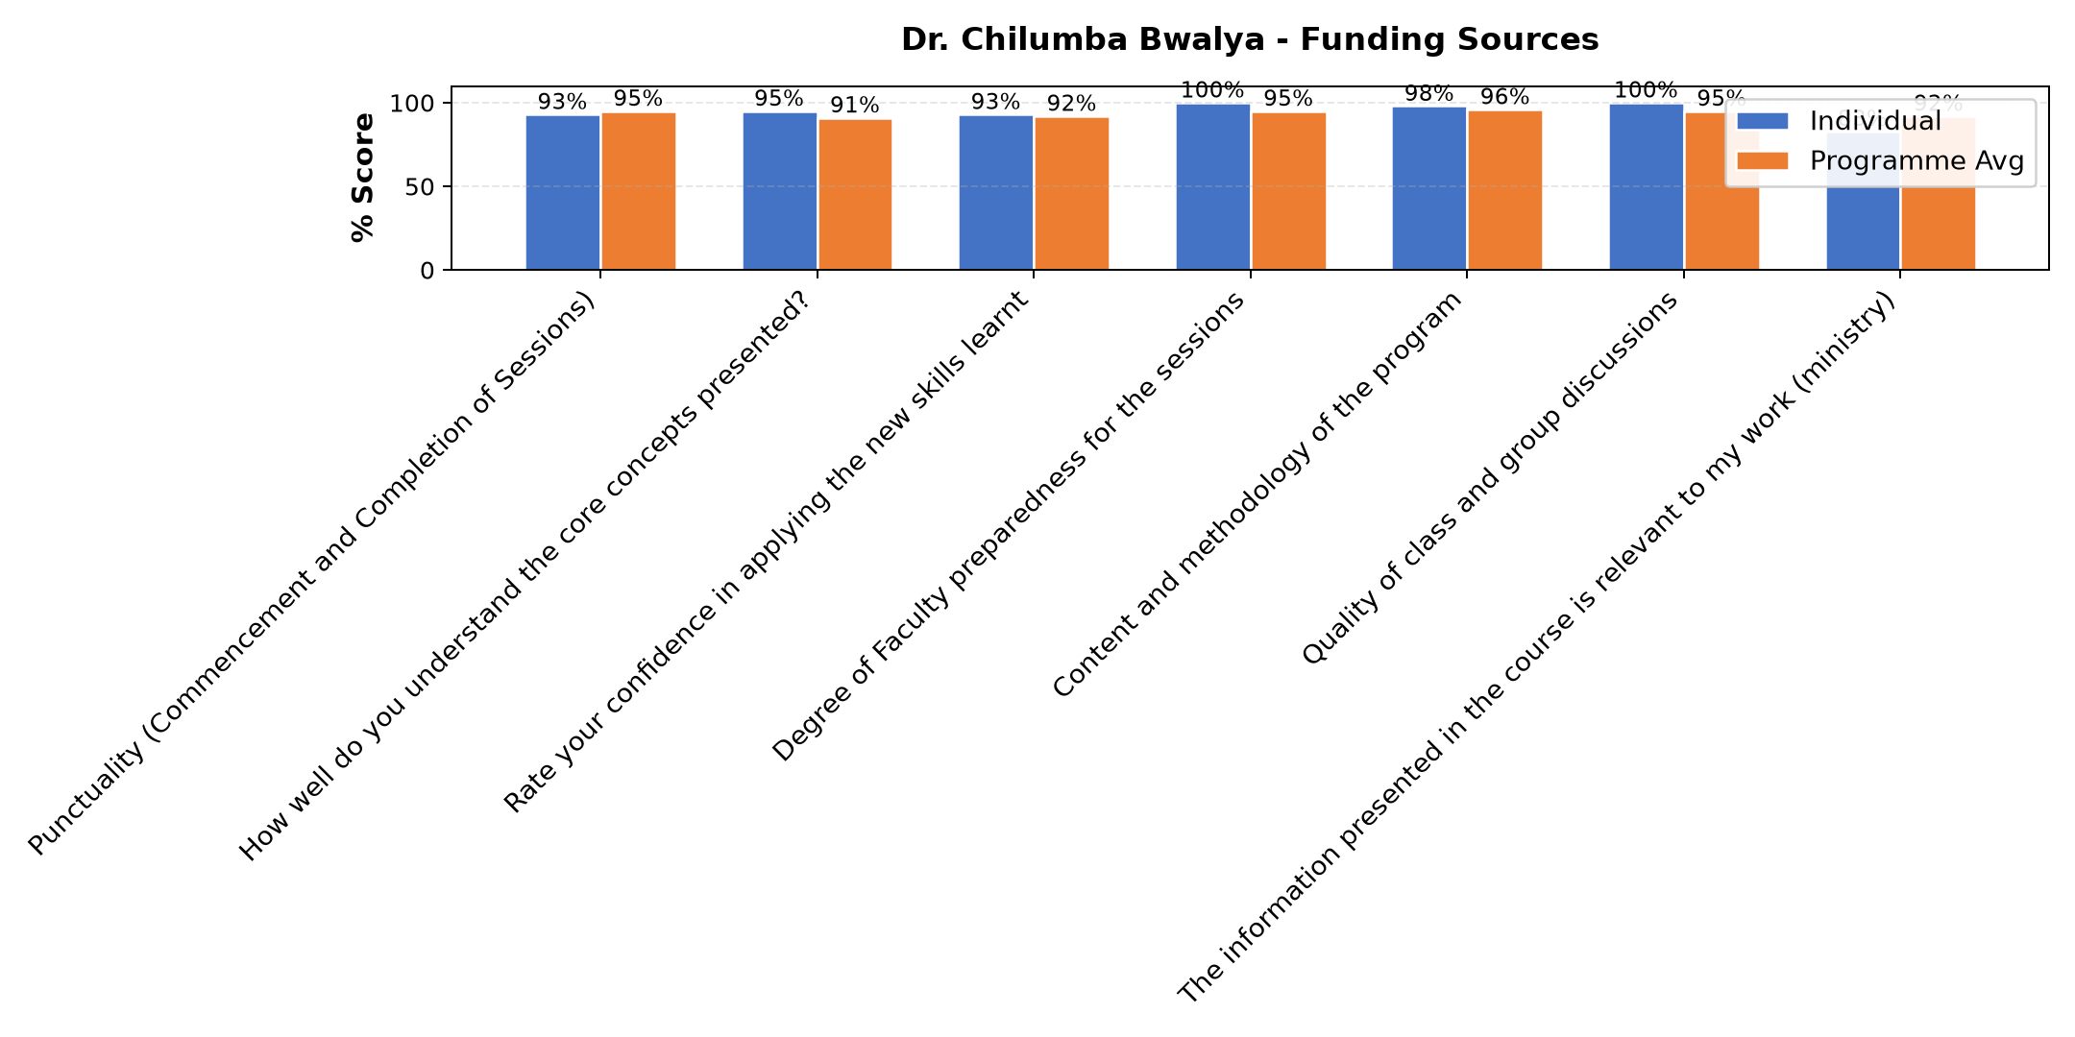

Comments & Feedback
- • Thank you helped me to know how I can do better
- • The topic was very relevant and helpful
- • He has his own stale of teaching.
- • Excellent presentation
- • Am going to put what i have ben told into action and to present Excellent abed
- • Very helpful
- • All this that i have told in this course,i have to go and put it into action
- • The sessions were so interesting
- • We learnt were to go for funding and their requirements, we looked at the scale were we are as an enterprise, what we have done and what needs to be done.
- • We need to involve other stakeholders as to learn from them. Not to give up
- • When i checked the topic i was very happy unfortunatly i couldnt follow upto 6he end.
- • Your insight was great, very effective to our Enterprise especially in dealing with

Dr. David Mutua Mathuva - Governance and succession planning
Evaluation Parameter | (%) Individual Score | (%) Programme Average
Punctuality (Commencement and Completion of Sessions) | 92 | 95
How well do you understand the core concepts presented? | 92 | 91
Rate your confidence in applying the new skills learnt | 91 | 92
Degree of Faculty preparedness for the sessions | 92 | 95
Content and methodology of the program | 94 | 96
Quality of class and group discussions | 94 | 95
The information presented in the course is relevant to my work (ministry) | 91 | 92
Average scores | 92 | 94

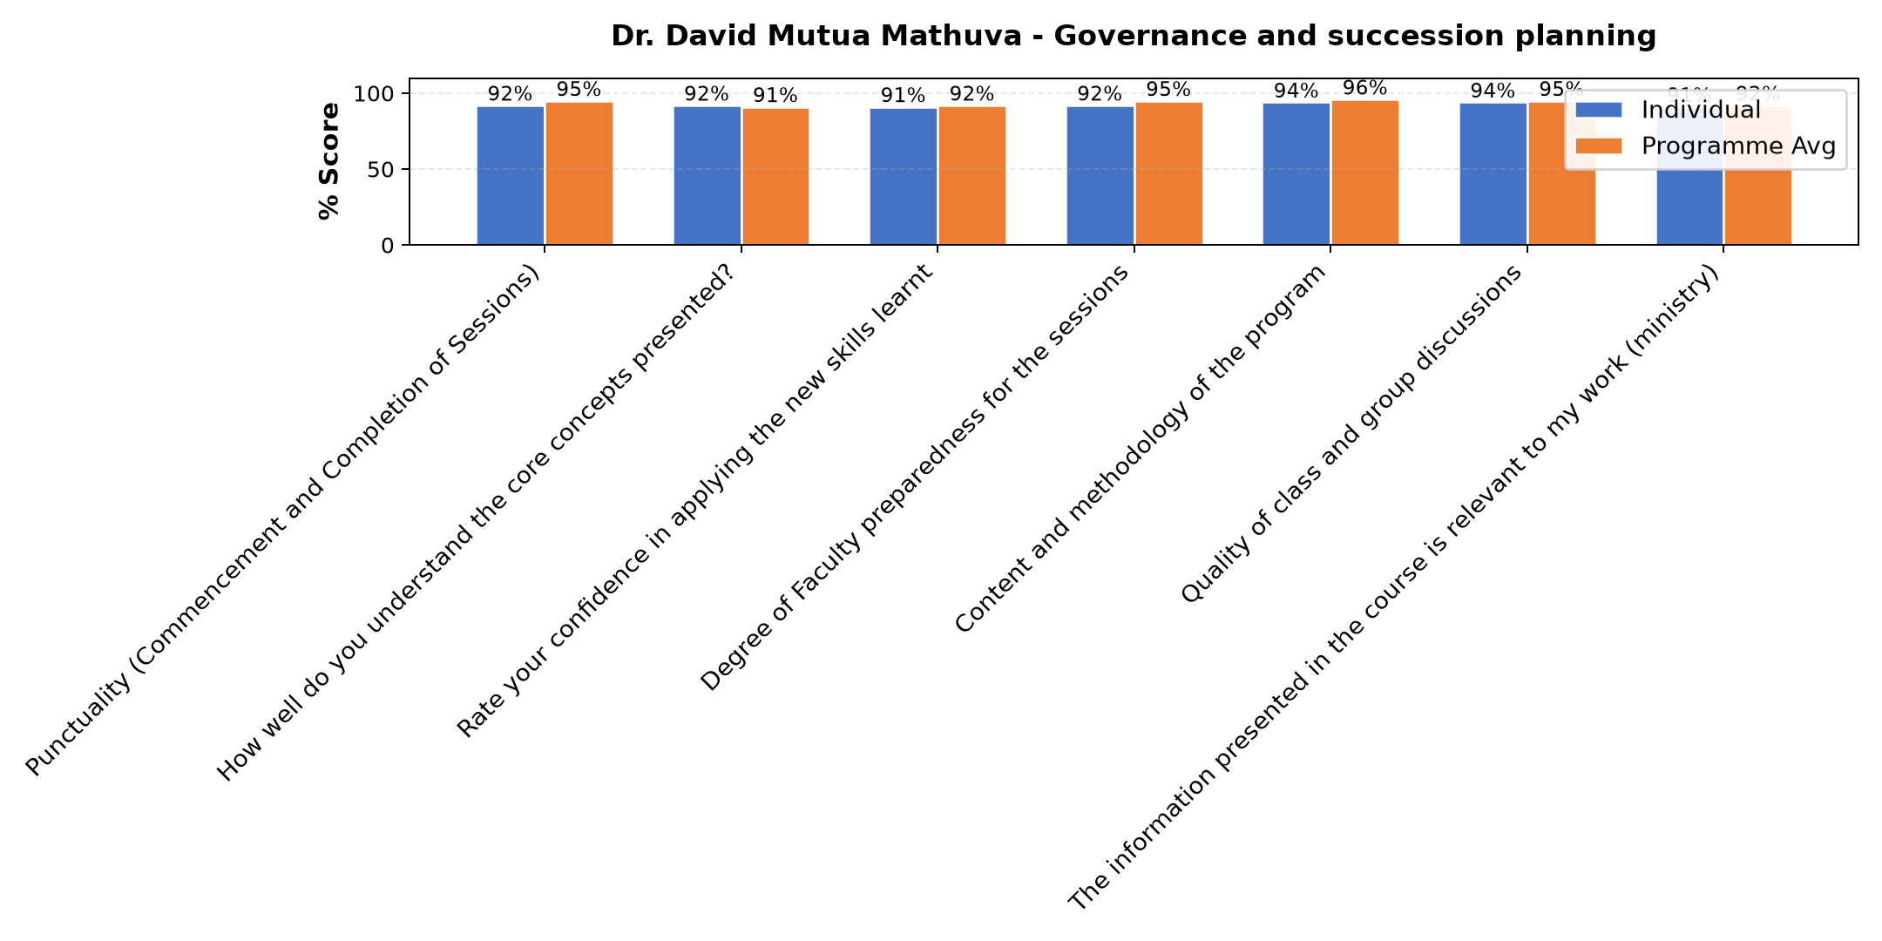

Comments & Feedback
- • No barriers will prevent me to applying it,i have learnt how to ,plan and to sale my business
- • Nothing because it's so inspiring
- • Thank a lot. The day last day was wonderful. Learning of what ZRA. I learnt how they operate in order to maintain the country 's economy and Budget how the money will be divided to different ministries and the different types of Tax that are to be paid and that you can as well be exempted from paying Tex.
- • As well an understanding mind that if not able to pay may go to the offices to let them know you are unable to pay.
- • Thanks to Dr Nancy for the highlights to finish our enterprise planning and to Dr. William to make aware of the people we can interact with who can be influencial to our enterprise in a positive way or negative way and who can take over when the person in charge has been transferred or died. Thanks as well to SR Slestine for making it a point on the leadership as well on the synod of hope.
- • Thank you so much for your insight
- • It might be time or resources but I will try to level to utilize what I have learned
- • The challenges of audibility interfered with concentration.
- • Finances
- • Lecture was very good

Isaac Kipkosgei Kigen - IT and Technology
Evaluation Parameter | (%) Individual Score | (%) Programme Average
Punctuality (Commencement and Completion of Sessions) | 100 | 95
How well do you understand the core concepts presented? | 90 | 91
Rate your confidence in applying the new skills learnt | 90 | 92
Degree of Faculty preparedness for the sessions | 100 | 95
Content and methodology of the program | 100 | 96
Quality of class and group discussions | 100 | 95
The information presented in the course is relevant to my work (ministry) | 100 | 92
Average scores | 97 | 94

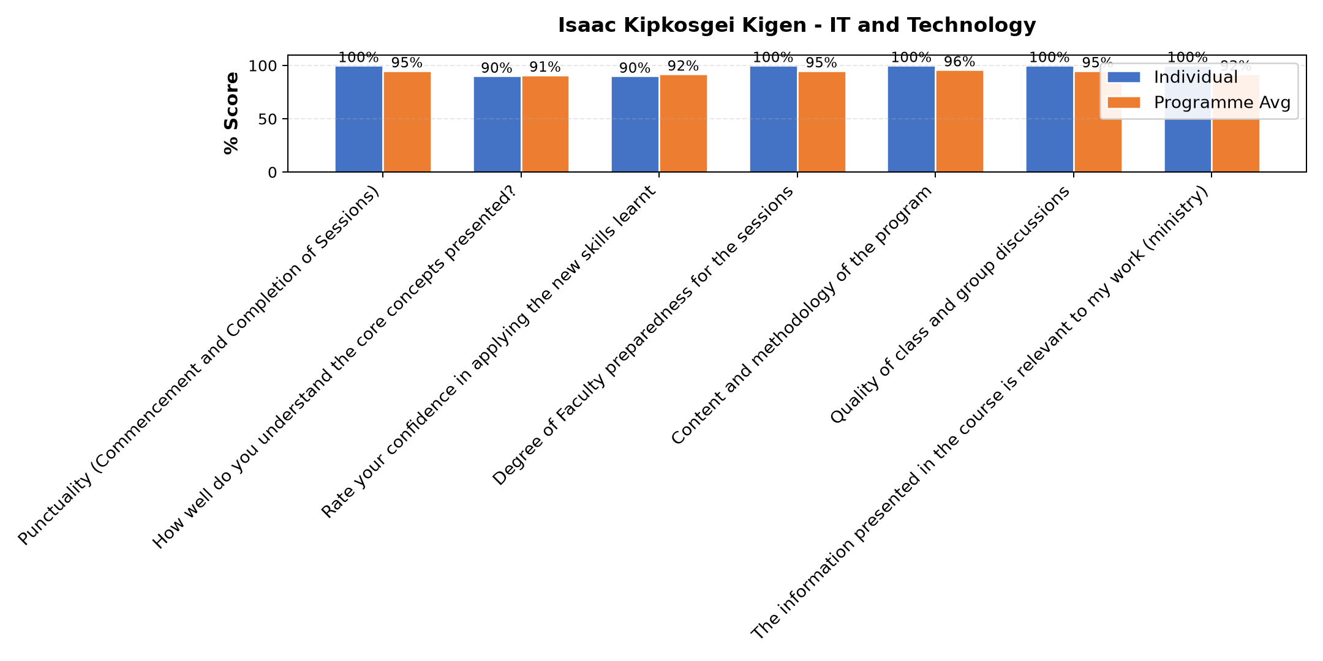

Comments & Feedback
- • Even though today the network did not allow much tomorrow it will be better
- • very come and patience.
- • More time for practice
- • It was very effective to my project
- • Thanks
- • i want to learn more about iT
- • This was an excellent practical and informative Topic
- • Very good and well done
- • The lesson was interesting
- • It a very educative and helping topic
- • Well kectured

Felix Mogesa Motari - Operations and Efficiency
Evaluation Parameter | (%) Individual Score | (%) Programme Average
Punctuality (Commencement and Completion of Sessions) | 95 | 95
How well do you understand the core concepts presented? | 92 | 91
Rate your confidence in applying the new skills learnt | 93 | 92
Degree of Faculty preparedness for the sessions | 92 | 95
Content and methodology of the program | 93 | 96
Quality of class and group discussions | 93 | 95
The information presented in the course is relevant to my work (ministry) | 92 | 92
Average scores | 93 | 94

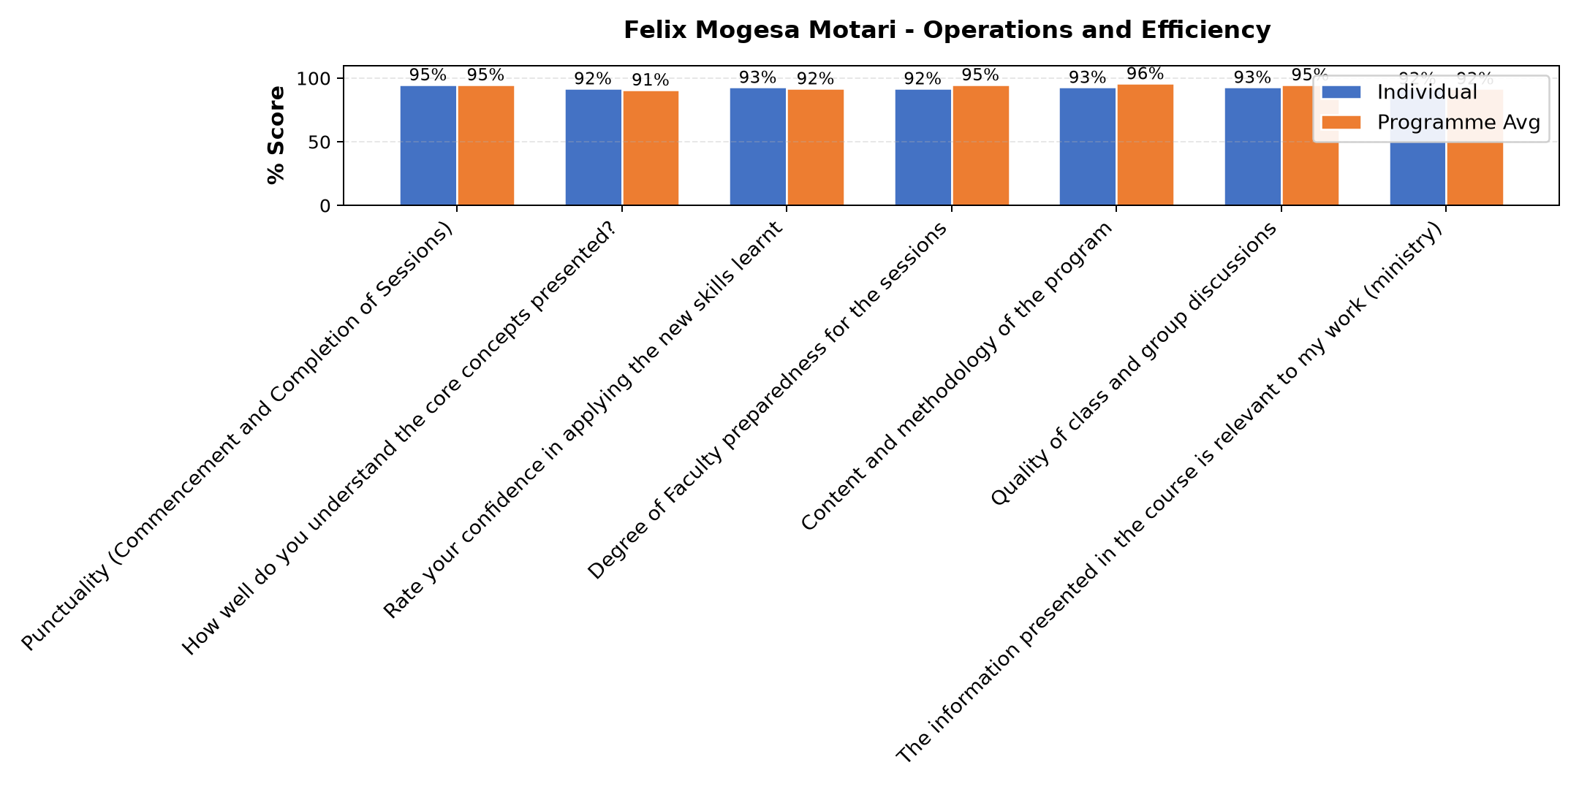

Comments & Feedback
- • Good lecture
- • It was great thanks, very effective to my project
- • Thanks
- • Well presented
- • Today was great thank you. We learnt how to identify operational efficiency and objectives in our enterprises. Things that we have not been doing well to improve as well things that we have done that need continuing. Just like yesterday we need to keep records in order to identify the demands as well to reach the capacity through developing strategies.
- • To see how transportation affects us in positive way as well in negative way due to challenges faced on the road network
- • I have learnt what TIMWOODS can do if we evaluate on our enterprise using this tool.
- • Mostly to keep records on all to help see where things have gone wrong in our enterprise.
- • Thanks for all the information given we need more time and practice for this session
- • keep it up 👍❤️
- • The content where very relevantant
- • Mr. Mogesa can do better in future
- • We need to have Todays this Topic

Department Reports

Overall Evaluation
Evaluation Parameter | (%) Score
Overall program evaluation | 98
Average score | 98

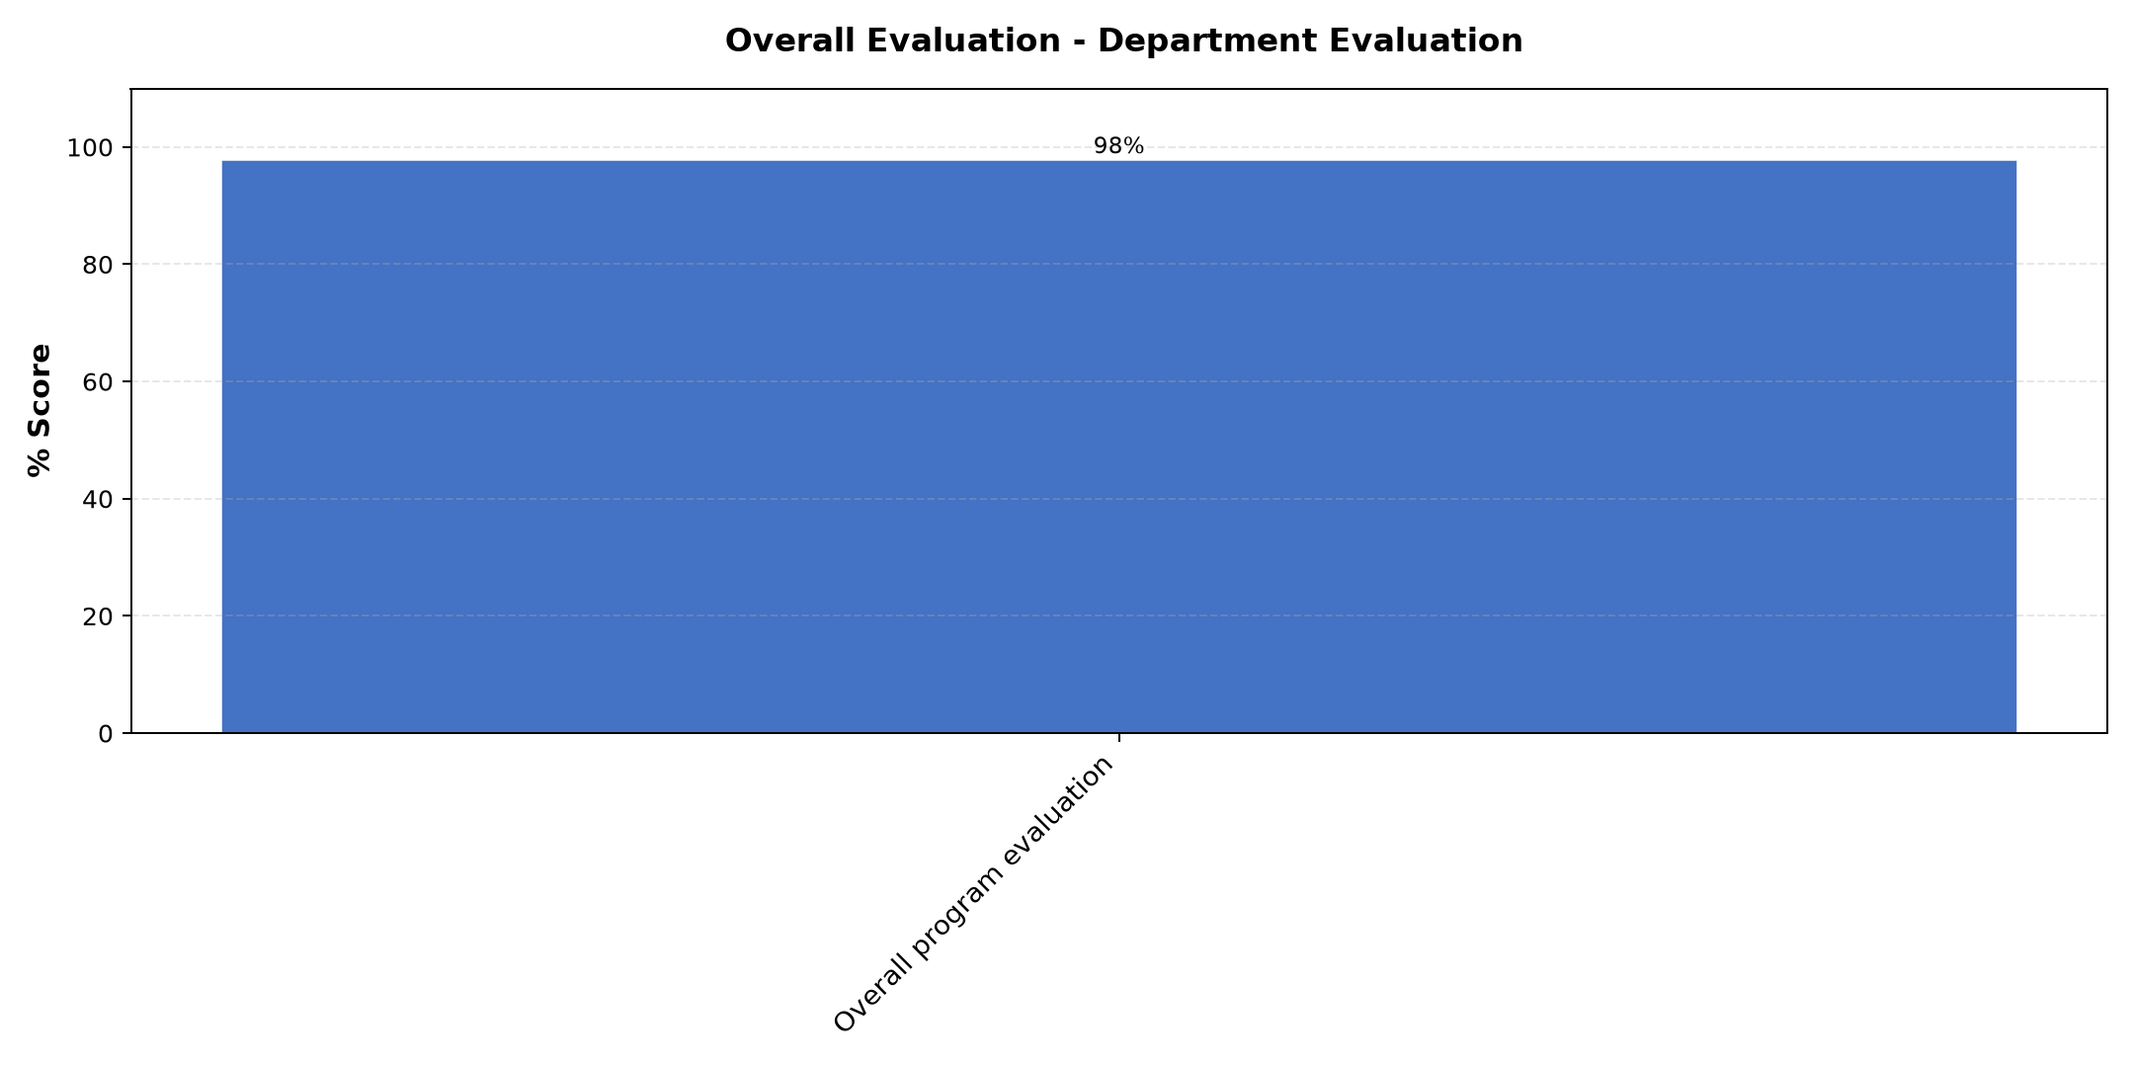

Comments & Feedback
- • All was the best
- • How l will fund my resources and succession plan
- • The areas of improvement in some online classes
- • planing,budget,andpreparations
- • We need more time
- • The week was very helpful and we have learnt a lot. We met new professors
- • Thank you so much, well organized
- • More days can be added

Program Manager (Paul Bikundo)
Evaluation Parameter | (%) Score
Punctuality in sending materials and programme information | 100
Communication skills(verbal and written) | 100
Response to programme enquiries via email, whatsapp and calls | 100
Accessibility and willingness to support when needed | 100
Quality of service / professionalism | 100
Suitability of training venue (space, layout, facilties) | 100
Average score | 100

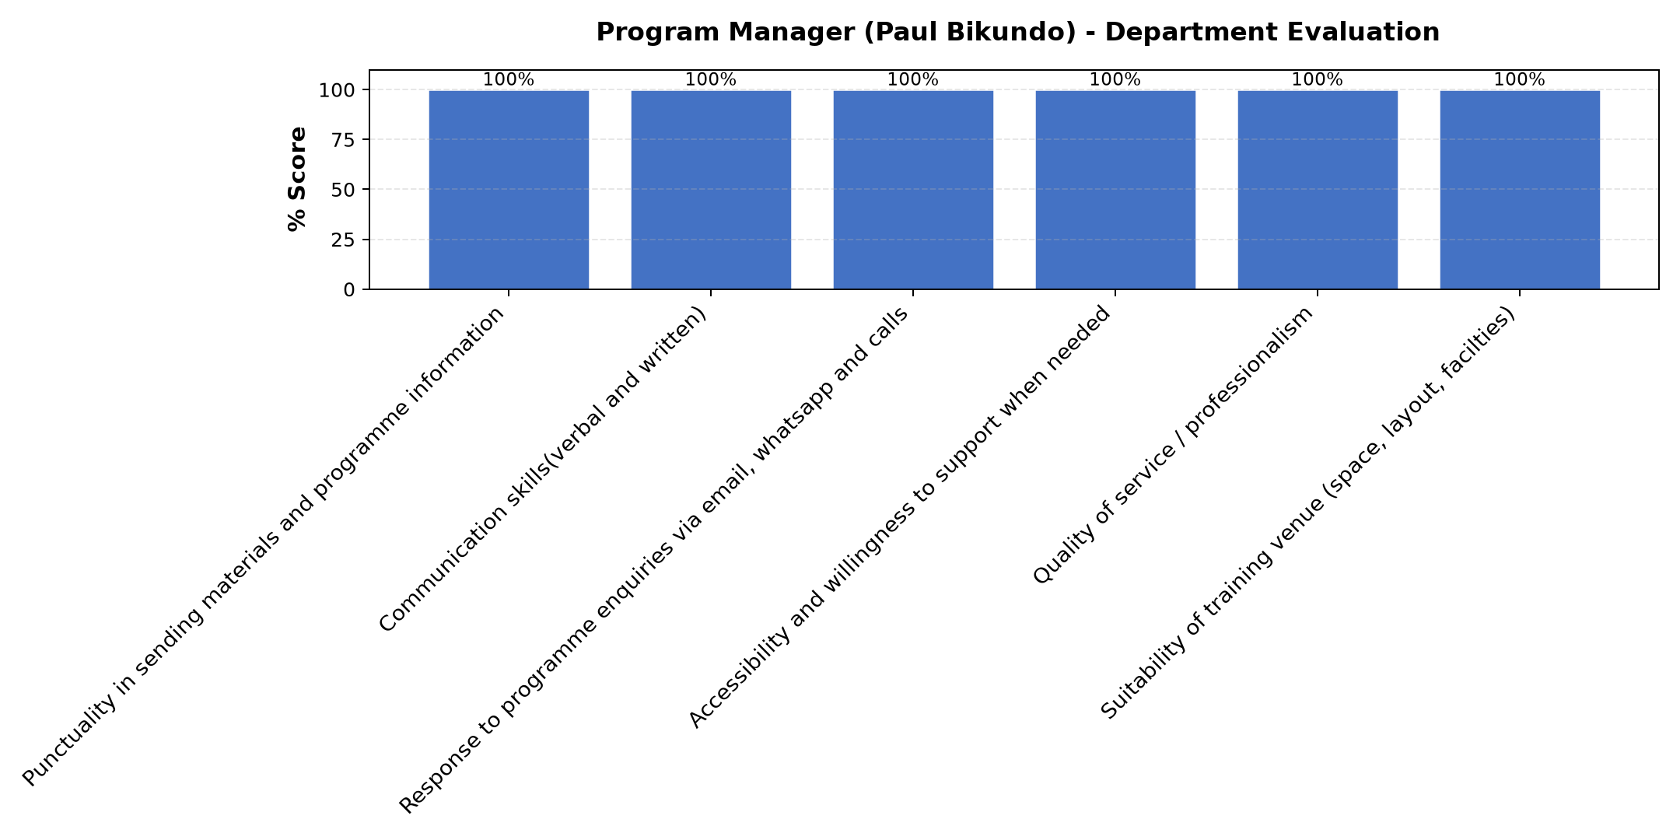

Comments & Feedback
- • The inputs were very helpful and enhanced my understanding social impact my vocation calls me to.
- • He is good organizer
- • The sessions have helped me to see blending value with a different eye
- • His a very good communicator
- • IThank
- • Excellent work and impowering to achieve the goal
- • Keep it up
- • Thanks a lot. I have learnt that you can do a lot depending on dedication like the Sisters of Mary who built a hostel in a short time.
- • Went well
- • Thanks so very much Mr Paul, for everything I learned a lot, and I hope to improve our Enterprise especially in the areas where we need to improve thanks again God bless you abundantly.
- • The all program was very argamized, continue with the tha spirit .

Are there any other comments and/ or suggestions that you may want to add?

Comments & Feedback
- • This is a wonderful course I can suggest that more sisters should be trained in this course
- • How to assecc program and planning better
- • Thanks a lot
- • Just a word of gratitude to the team at Strathmore university.
- • Thank you so Much for Everything God bless you continue with the same spirit of helping others

Areas found most relevant and practical to business

Comments & Feedback
- • Not planning is planning to fail. How technology can complement my work. Knowing my why, what and how is key successfully have a lasting positive social impact.
- • Will put in practice want I lent
- • Funding sources
- • Module 3
- • no
- • planning and organize
- • Sustainability, planing
- • The importance of paying Tex and the consequences of not paying. The Highlight from Dr. Nancy and SR
- • Will put in practice
- • Almost everything was relevant to our Enterprise especially on funding sources.
- • All topic where relevant and applicable to the business

Teaching methods applied enjoyed/ learnt from the most

Comments & Feedback
- • Physical meeting or on sight lectures.
- • It was All okay
- • Group discussion
- • Physical lecturer
- • Yes
- • IT PROGRAM IS VERY INTERESTING
- • Class engagement
- • Was okay
- • Learnt
- • Teaching methods used eg: Lecture discussion and group works

Topics recommended to be expanded or improved in this module/unit

Comments & Feedback
- • All are just OK for this level.
- • Still digesting I lent
- • Governance and succession
- • Operational and efficiency
- • I thank you for this project,may the Lord bless you at all times
- • planning and social impact
- • IT, funding sources
- • All was well
- • On social impact.
- • On IT

